Team RavenClaw – Project Proposal

Our team decided to pursue the Data Visualization track of this project. With that in mind, we found several datasets which we thought would be interesting to analyze. One of which is a dataset which contains the names and demographic information of inmates that have been executed on death row. Another, contains data specifically from executed inmates in Texas and includes demographic information as well as their last words. Our datasets can be found at:

[Execution Database | Death Penalty Information Center](https://deathpenaltyinfo.org/database/executions)

<https://www.kaggle.com/datasets/srivastavaprakhar07/texas-deathrow-full-dataset>

We plan on using the datasets to create immersive visualizations that a user can toggle and adjust at will. We want to house these visualizations through a Github Page so it functions like a website. We wanted to create 3 specific visualizations:

*We wanted to create a “last words” of executed inmate quote generator. This would work like any quote generator website where the user lands on the website and a random quote appears. They would then have the option to click and have new randomly generated quotes appear at will. Example:

*We also wanted to generate a GeoJson of all 50 states which showed how many inmates were executed in each particular state.

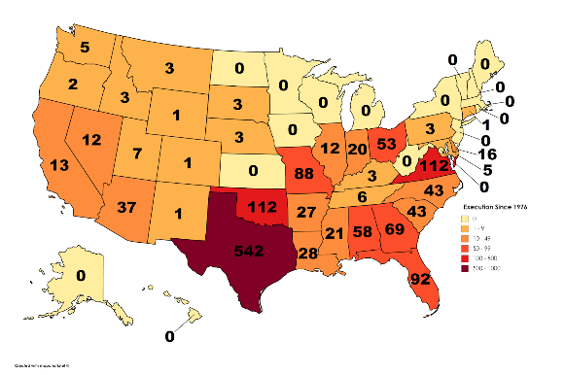

*Lastly, we wanted to create visualizations using Matplotlib as well as Seaborn which will answer a number of demographic questions. For example, what is the percentage of inmates that have been executed that are male, white, education level, age, etc. Using Seaborn, we wanted to perform an analysis that would determine whether the state a person lives in statistically correlates with a person ending up on death row.

Since our data is all relational, we plan on loading our data / creating a database using PostgreSQL. We plan on analyzing data using Jupyter Notebook and finally building our website using JavaScript as well as HTML code.

The link for our github where our data will be stored is:  
https://github.com/DDragan24/Project-3-TeamRavenClaw.git